

Press Release – February 12 or 13, 2025

RURALITIC: Rethinking European Rural Areas in the face of new realities, challenges and transitions

European rural areas are undergoing profound socio-demographic changes, shaped by ecological, digital, and bio-economic transitions. Accelerated by the Covid-19 pandemic, these transformations highlight the increasing diversification of rural territories, making them as complex and varied as major cities. However, existing tools, concepts, and public policies struggle to grasp this evolving reality. The RURALITIC project, coordinated by INRAE and bringing together 16 partners from 10 countries for 4 years of research and action, aims to shed light on these dynamics and support the development of tailored public policies.

The evolving nature of rurality calls for a reassessment of its definition and role within broader territorial dynamics. Socio-demographic shifts, climate change, digitalisation, and evolving mobility patterns are reshaping rural landscapes, creating both opportunities and disparities. While some rural areas benefit from new economic and social dynamics, others face increased marginalisation. Addressing these challenges requires a nuanced approach that moves beyond conventional classifications and embraces the diverse realities of rural spaces.

Understanding and transforming rural territories
RURALITIC is based on a conceptual redefinition of "the rural" to develop new scientific and methodological tools. It will produce new data, surveys, indicators, and typologies, allowing for a refined analysis of contemporary rural dynamics. These frameworks will be used to assess the drivers of rural attractiveness, existing public policies, and innovative initiatives.
The RURALITIC programme will focus on defining the "European rural social spaces," highlighting the relationship between the economic and cultural capitals of its inhabitants, while examining the links between social positions, life trajectories, and perceptions of places.
Key objectives for concrete action
To achieve these ambitions, RURALITIC has set six main objectives:
- Redefining rurality as a multidimensional and relational concept, emphasising socio-economic and spatial interdependencies.
- Characterising the diversity of rural areas and their role in major transitions by integrating new indicators (real estate trends, digitalisation, environmental amenities) and focusing on evolving social dynamics.
- Identify key drivers of attractiveness specific to different types of rural areas and assessing how crises and policies shape population flows and perceptions.
- Evaluating post-Covid demographic impacts on public services, real estate markets, and well-being, with a focus on financial sustainability and social coherence.
- Assessing and co-developing public policies and local initiatives to revitalise rural areas.
- Developing future scenarios that envision resilient and thriving rural areas, where tradition, innovation, and environmental stewardship intersect to create sustainable socio-economic models.
As territorial inequalities widen and tensions over land use grow, RURALITIC offers a renewed approach tailored to the specificities of each rural area. The goal is to provide policymakers with science-based recommendations to foster balanced and inclusive development. Overall, the project will feed into the European Commission’s Long-Term Vision for Rural Areas which aims to create stronger, connected, resilient, and prosperous rural areas by 2040. It will do this by empowering rural communities, improving digital and physical connectivity, enhancing environmental sustainability and climate resilience, and fostering economic diversification.
Over its 48-month duration, the project aims to reshape public policies towards a more precise and adaptive approach to the realities of European rural areas.

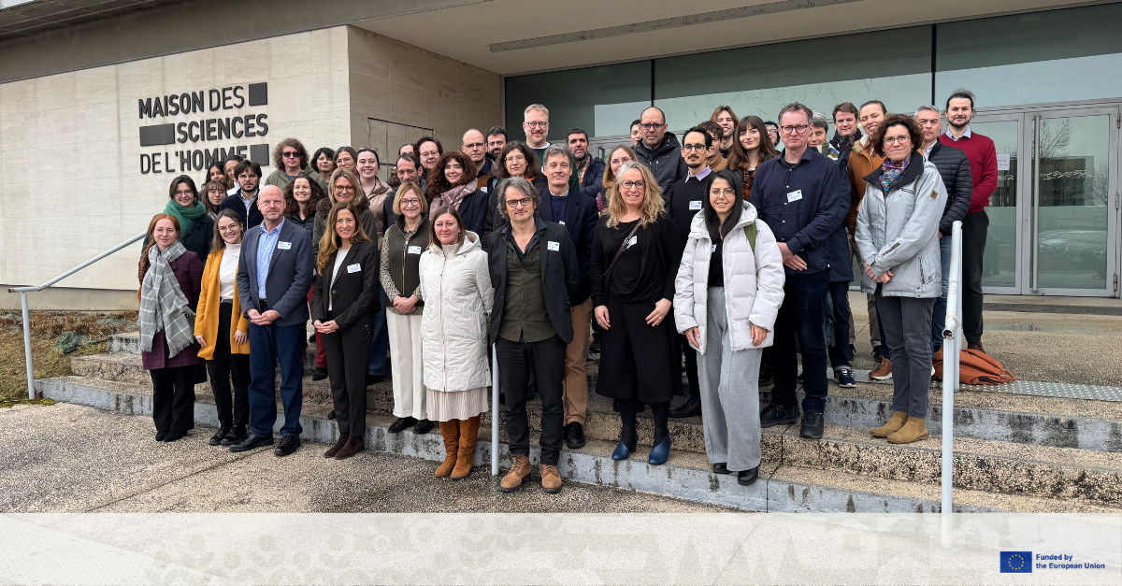

Project features
RURALITIC Rural revival: a life in the inspirational countryside
Coordination by INRAE – 16 partners : INRAE + IA (FR), TUD (NL), FLUP (PT), Ined (FR), EUR (NL), US-EPRC (UK), U Lyon 2 (FR), UU (SE), RUC (DK), UAB (ES), UWK (AT), IRWiR (PL), ARCTIK (BE), IT (FR),IfA (UK), CDAF (FR)
European funding under Horizon Europe: € 6 494 227

Horizon Europe project no. 101181142
Project website: https://www.ruralitic.eu/
LinkedIn : https://www.linkedin.com/company/ruralitic-eu/
BlueSky : https://bsky.app/profile/ruralitic-eu.bsky.social
Zenodo : https://zenodo.org/communities/ruralitic/records?q=&l=list&p=1&s=10&sort=newest

Scientific contact:
Gilles Laferté - gilles.laferte@inrae.fr
Joint Research Unit « Center for Economics and Sociology Applied to Agriculture and Rural Areas »
Research Division Economics and Social Sciences for Agriculture, Food and Environment (ECOSOCIO)
Research Centre INRAE Bourgogne Franche-Compté

Press contact:
INRAE Media Relations: 01 42 75 91 86 – presse@inrae.fr
__________________________________________________________________________________

The French National Research Institute for Agriculture, Food, and Environment (INRAE) is a major player globally in research and innovation on agriculture, food and the environment. The institute brings together a community of over 10,000 people, including 8,000 permanent staff and more than 2,500 project-funded contractors each year, working across more than 270 research, service, and experimental units located in 18 centers throughout France.
Internationally, INRAE is among the top research organisations in the agricultural and food sciences, plant and animal sciences, as well as in ecology and environmental science. INRAE’s goal is to be a key player in providing the knowledge base supporting the necessary acceleration of agricultural, food and environmental transitions, to address the major global challenges.

Paris head office
147, rue de l’Université
75338 Paris Cedex 07 - France
Tel.: +33 1 (0)1 42 75 95 43

www.inrae.fr/en

